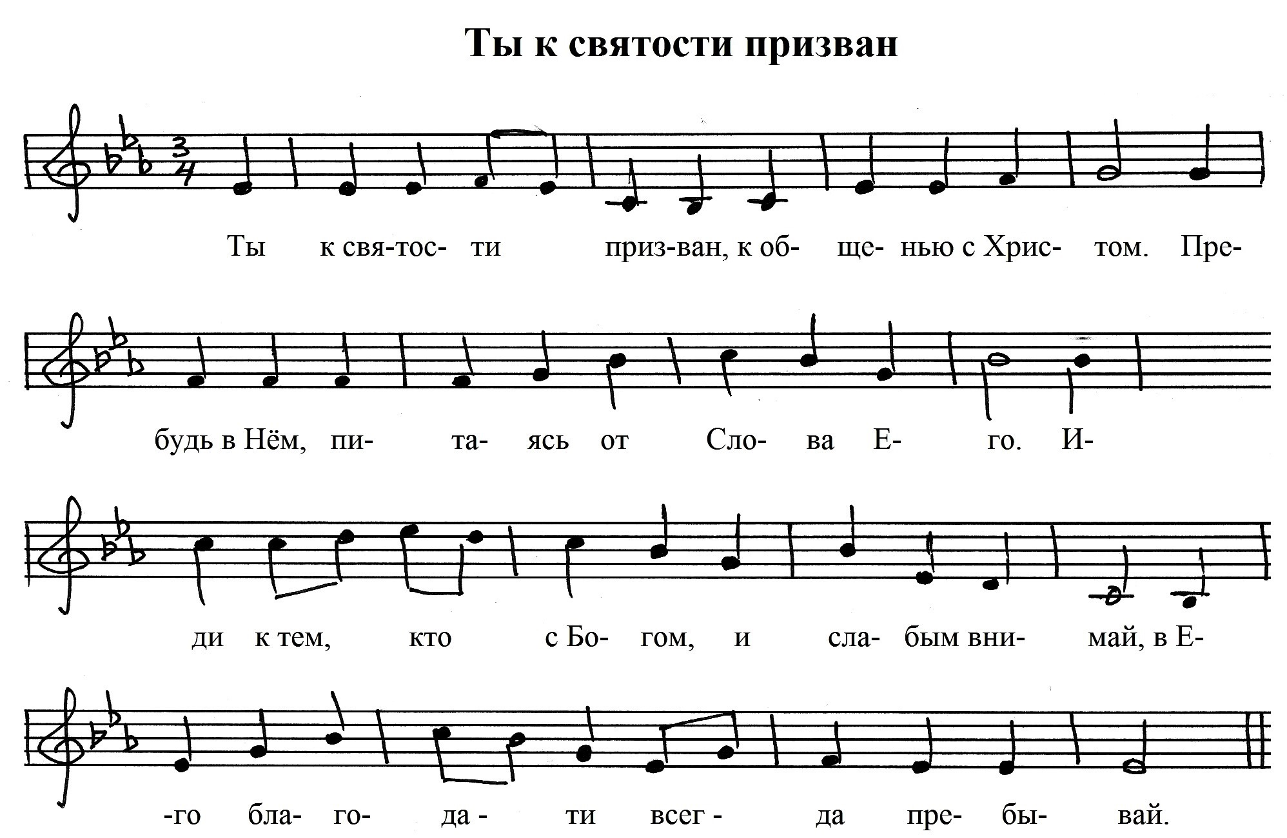

**As Es Cm Gm As B**

**B B Es B Cm Gm B**

**Es As Es B Es**

**Es Cm As B7 (sus4) Es**

Аккорды к фонограмме